Supplementary material

Figure S1 – Dixon plot of the assay results from compound 5 with type II dehydroquinase (S. coelicolor).

Figure S2 – Dixon plot of the assay results from compound 7 with type II dehydroquinase (S. coelicolor).

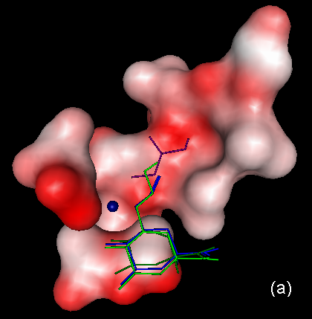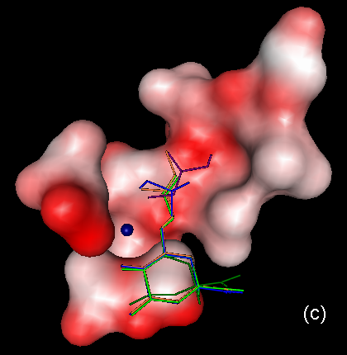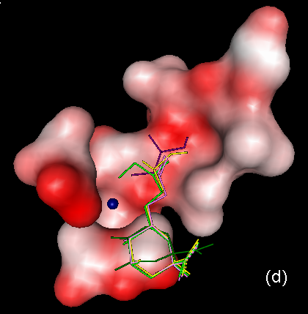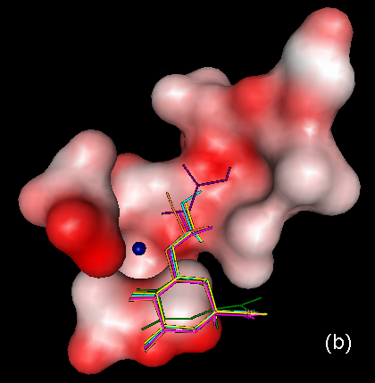

Figure S3 – Results from the docking experiments with GOLD1.2: positions of the ligands in the active-site of type II dehydroquinase (S. coelicolor), compared with the positions of glycerol (purple) and 3 (dark green). (a) 5 (dark blue) and 7 (light green), (b) 6 (two diastereomers, R – pink, S – yellow) and 8 (two diastereomers, R – light blue, S – orange), (c) 9 and 10 (two diastereomers, R – dark blue, S – orange) and (d) 11 and 12 (two diastereomers, R – light green, S – yellow).

